Installing Kali Linux on your M1 apple silicon MacBook - by Kyle Ford many thanks to some hero on Github named Hvaandres

1. GET UTM

UTM – virtualization software - $10 in Appstore( Appstore cost money) or Free on <https://mac.getutm.app/>

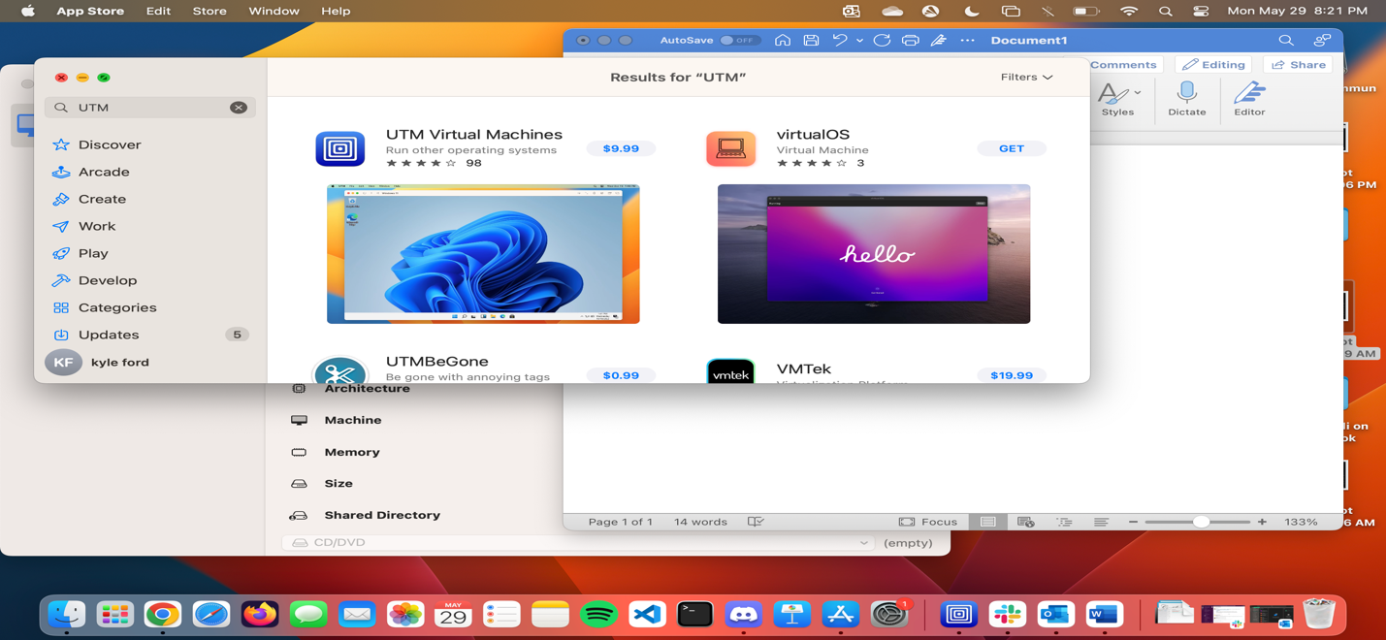

* Straight forward instillation process

1. Get ISO file for the operating system you want to install, We’re looking for Kali Linux,

* Go to <https://www.kali.org/get-kali/#kali-installer-images>
* Select the approaite file to mac the Operating system and hardware for the computer you are going to host / run the Kali virtual machine on.
* If you have a Mac with the M1 chip, then Select Apple Silicon (ARM64)
* I used the down arrow download icon rather than torrent ( personal preference).
* A screenshot of a computer

  Description automatically generated

If you try to do a normal install you will end up with a black screen terminal window at the end of the process

This is caused by a know issue that can be resolved by following the instruction below that I found here <https://github.com/utmapp/UTM/discussions/4539> by the Github user :

Hvaandres on.

In summary > You add a serial device > this lets you use a command line to do the installation, then you add you display device after following the instructions below

The solution to this problem is the following:

1.- You will have to choose: The display option | Emulated Display Card - virtio-ramfb  
2.- Add a Serial under Devices from the settings options of the VM  
3.- You will get a screen asking you what type of software you want to install. Then, you will have to install Kali Linux without any software, you will have to uncheck all of the software that has been checked by default.  
4.- After you get a prompt window with "The installation is ready" You have to eject the ISO image  
5.- Restart the machine, and login with your credentials  
6.- Run the following commands:

sudo apt update

sudo apt install -y kali-desktop-kde

sudo update-alternatives --config x-session-manager

[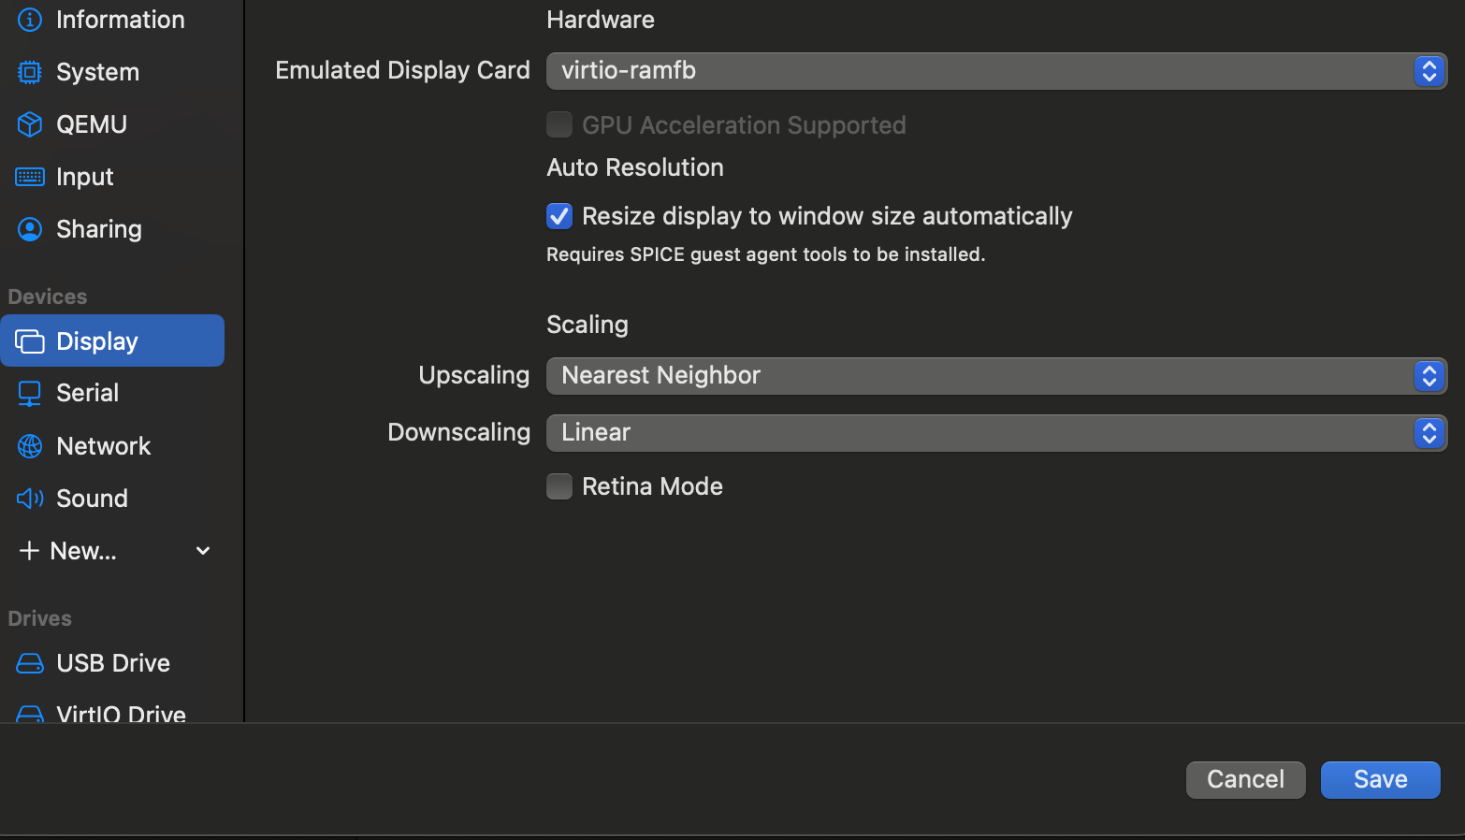](https://user-images.githubusercontent.com/26829975/212521980-c7507d26-1eef-4253-9867-d3bcc12ef650.png)

[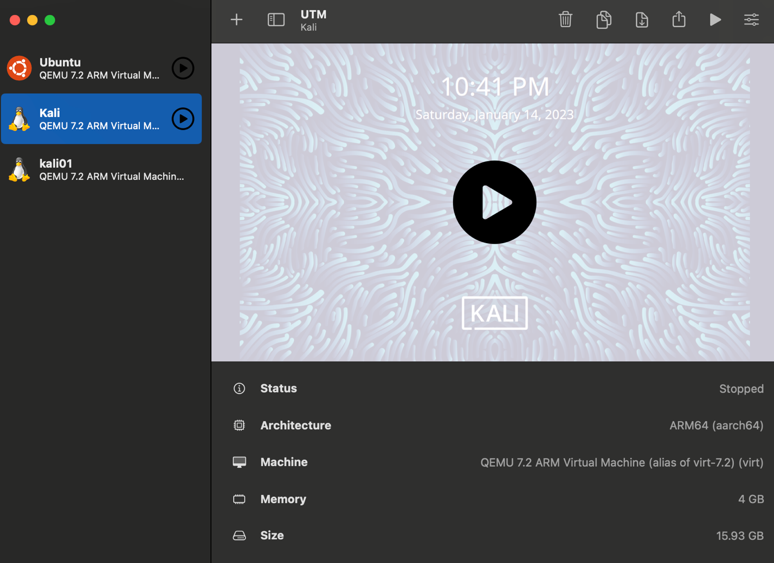](https://user-images.githubusercontent.com/26829975/212522032-9be29439-e7af-4f33-a98d-3064232217f3.png)

[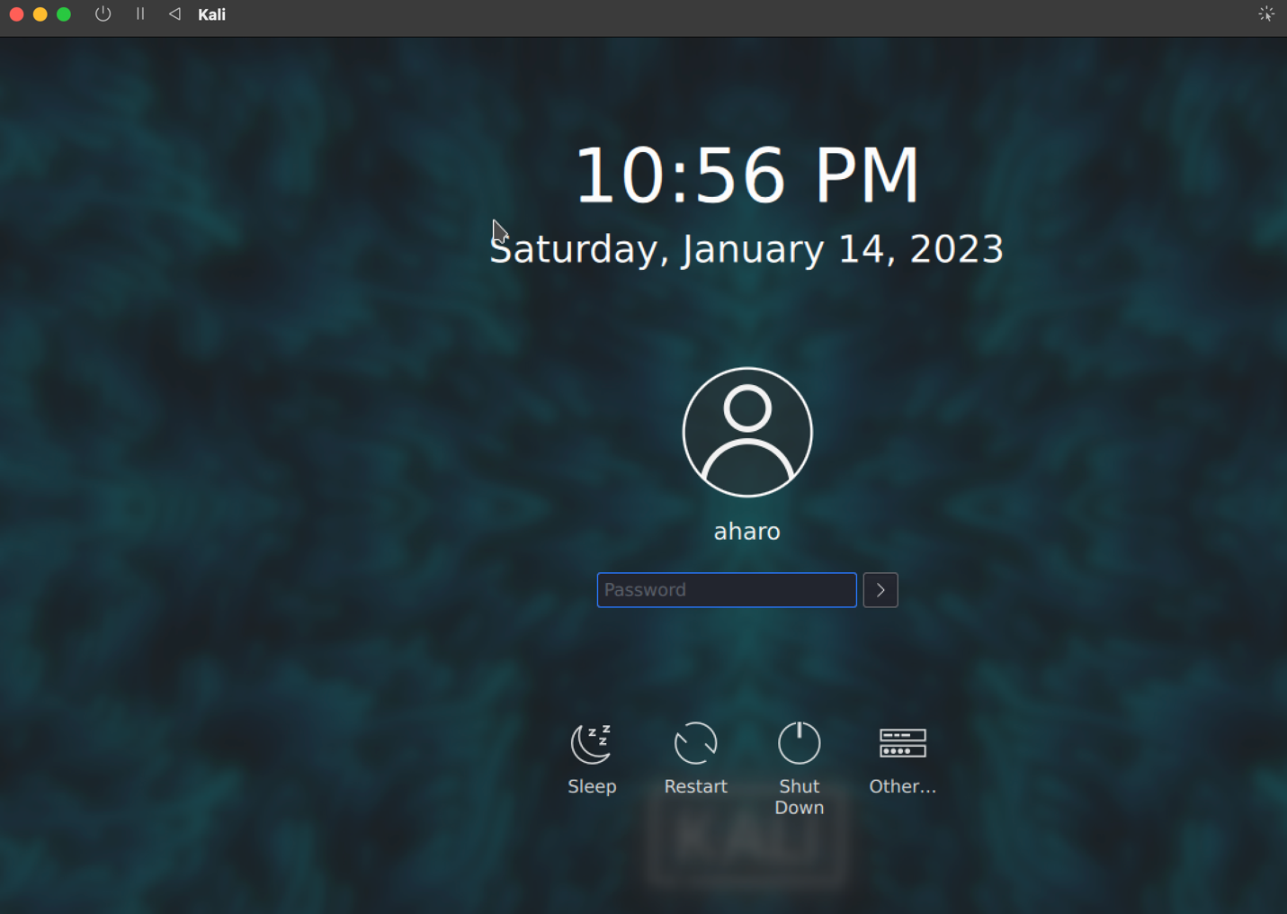](https://user-images.githubusercontent.com/26829975/212522154-30e5065d-5ea7-4553-818c-5524f4a6d0e1.png)

This will solve the black screen. I just downloaded the latest version of Kali and UTM, please ping me if you have any questions. If you would like to watch a video about this, you can check out this link [How to install kali Linux through UTM](https://www.youtube.com/watch?v=C-Aa8_iB5Xs) OR [check out my blog about this issue](https://ithvaandres.medium.com/black-screen-while-installing-kali-linux-on-macs-m1-m2-through-utm-5d5939d93577)

NOTE to eject the ISO file after install of the Kali Operating system, find disk icon(top right) >eject

